HOSPITAL MANAGEMENT SYSTEM

A PROJECT REPORT

Major Project – II (01CE0807)

Submitted by

MEET KHANESHA

92100103180

BACHELOR OF TECHNOLOGY
in

Computer Engineering



Faculty of Technology

Marwadi University, Rajkot
April, 2025



Major Project-II (01CE0807)
Department of Computer Engineering
Faculty of Technology
Marwadi University
A.Y. 2024-25
CERTIFICATE
This is to certify that the project report submitted along with the project entitled HOSPITAL MANAGEMENT SYSTEM has been carried out by MEET KHANESHA (92100103180) under my guidance in partial fulfilment for the degree of Bachelor of Technology in Computer Engineering, 8th Semester of Marwadi University, Rajkot during the academic year 2024-25.

Prof. Dhara Joshi | Dr. Krunal Vaghela
Assistant professor | Professor & Head
Department of Computer Engineering | Department of Computer Engineering

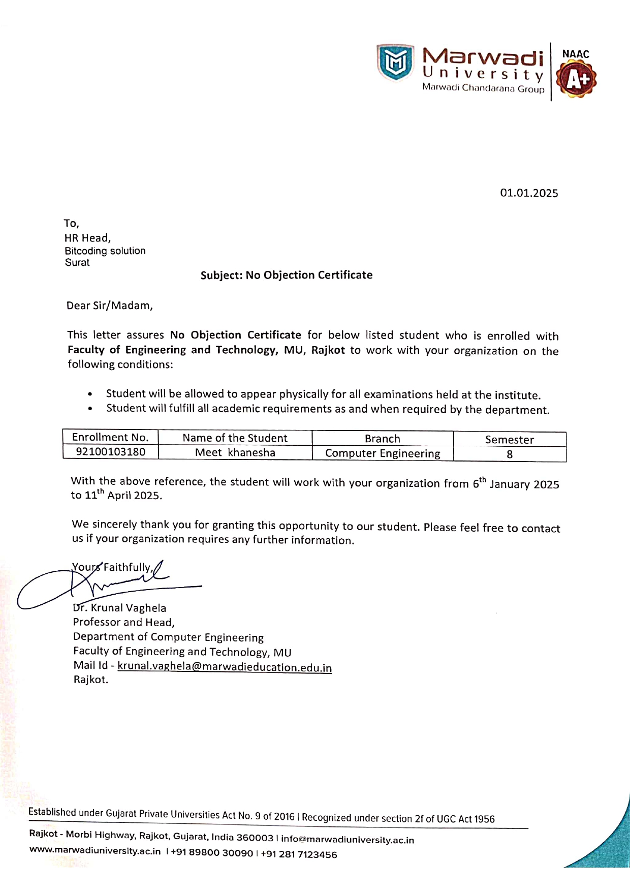

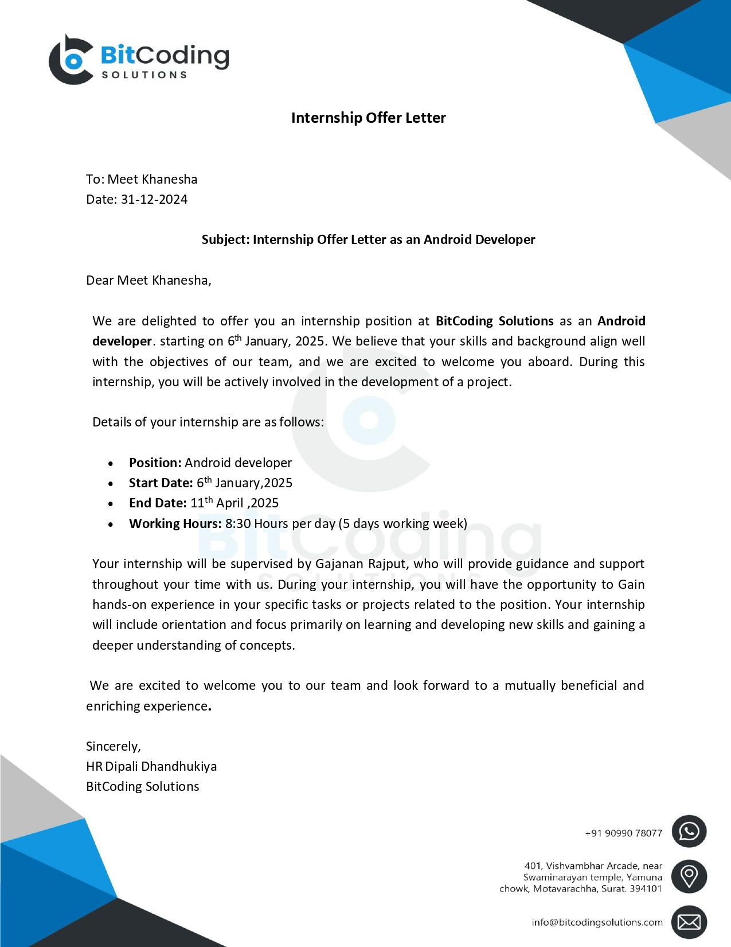





Major Project-II (01CE0807)
Department of Computer Engineering
Faculty of Technology
Marwadi University
A.Y. 2024-25

DECLARATION

We hereby declare that the Major Project-II (01CE0807) report submitted along with the Project entitled HOSPITAL MANAGEMENT SYSTEM submitted in partial fulfilment for the degree of Bachelor of Technology in Computer Engineering to Marwadi University, Rajkot, is a bonafide record of original project work carried out by me / us at Marwadi University under the supervision of Prof. Dhara Joshi and that no part of this report has been directly copied from any students’ reports or taken from any other source, without providing due reference.

Name of the Student Sign of Student

MEET KHANESHA _______________

Acknowledgement

Before proceeding to the contents of this module, I would like to express my heartfelt gratitude to my Internal Guide, Prof. Dhara Joshi, and my Head of the Department, Dr. Krunal Vaghela, who have been a continual source of inspiration throughout my journey. Their constant motivation, valuable insights, and unwavering support encouraged me to take on this project with confidence and enthusiasm. Their profound knowledge and expertise in the field of software development played a pivotal role in helping me successfully accomplish this internship project.
I extend my sincere thanks to Bitcoding Company for providing me with the opportunity to work on a live project titled Hospital Management System. This project allowed me to explore real-world problem-solving, apply technical concepts, and gain valuable hands-on experience in Android development and backend integration.
Lastly, I express my deep appreciation to all who directly or indirectly contributed to the successful completion of this project.

Abstract

The establishment and improvement of doctor-patient interaction system is a very important requirement, especially now when the communication technology is developing rapidly. The advantages of web can be made full use of to make up the time and distance gap between doctors and patients and to provide fast and adequate medical services. Through the connection between user terminals and specific service, both doctors and patients are able to obtain required data to achieve a better interaction. The platform, Web services and database technology are all gradually maturing, so that we can develop a doctor- patient interaction system on web application platform to meet the needs of the patient and provide doctors more efficient and convenient means of communication with patients.

List of Figures

Fig 1.1 Company logo…………………………………………………………………………1
Fig 3.1 Android studio………………………………………………………………………...6
Fig 3.2 Java…………………………………………………………………………………....6
Fig 3.3 XML…………………………………………………………………………………..6
Fig 3.4 Firebase logo………………………………………………………………………….6
Fig 3.5 Gantt chart…………………………………………………………………………….8
Fig 5.1 Flowchart…………………………………………………………………………….14
Fig 5.2 Use case diagram…………………………………………………………………….17
Fig 5.3 ER diagram…………………………………………………………………………..18
Fig 5.4 Sequence diagram……………………………………………………………………19

List of Tables

Table 5.1 Patient table………………………………………………………………………..16
Table 5.2 Doctor table…………...…………………………………………………………...16
Table 5.3 Appointment table…………………………………………………………………16
Table 5.4 Record table……………………………………………………………………….16
Table 6.1 Test cases………………………………………………………………………….37

 | Abbreviations
XML | eXtensible Markup Language.
UI | User Interface.
UX | User Experience
TC1 | Test cases 1
API | Application Programming Interface

Table of Contents

Acknowledgement……………………………………………………………..…………..… I
Abstract………………………………………………………………………….……………II
List of Figures………………………………………………………………………………..III
List of Tables……………………………………………………………………………….. IV
List of Abbreviations…………………………………………………………….…..……… V
Table of Contents………………………………………………………………….……..…. VI
Chapter 1 Overview of the Company
1.1 History…………………………………………………………………..………………… 1
1.2 Different product………………………………………………………..……………….... 1
1.3 Achievements…………………………………………………………………………..…. 2
Chapter 2 Overview of different department
2.1 Digital workplace……………………………………………………………..………..…. 3
2.2 Recent solutions………………………..……………………………………………..…... 3
2.3 Vision and Mission………………………………..………………………………..…….. 4
2.3.1 Vision…………..…………………………………..…………………..……….. 4
2.3.2 Mission………………………………………………………..……..………….. 4
2.4 Contact info…………………………………………………………………..………...…. 4
Chapter 3 Introduction
3.1 Internship Summary………………………..…...……………….…………….……….…. 5
3.2 Purpose………………………………………………..…………………………….….…. 5
3.3 Objective …………………………………………………………..……………….….…. 5
3.4 Scope…………………………………………………………………………..…….….... 6
3.5 Tool and Technology……………………………………………………………………... 6
3.6 Internship Project Planning………………………………………………………….……. 7
3.6.1 Internship Development Approach and Justification ………………...………. 7
3.6.2 Internship Effort and Time, Cost Estimation ……………………………...…. 7
3.6.3 Roles and Responsibilities …………………………………………...………. 7
3.7 Internship Scheduling………………………………………………..………...…...…… 8
Chapter 4 System Analysis
4.1 Study of Current System…………………………………………..………..…..………. 9
4.2 Problem and Weaknesses of Current System ………………………………………….. 10
4.2.1 Problem…………………………………………………………..…………….. 10
4.2.2 Weakness……………………………………………………….……………… 10
4.3 Requirements of New System ………………………………..……….………….……..10
4.3.1 Functional requirement………………………………………..………………...10
4.3.2 Non-functional requirement…………………………………..…………………11
4.4 System Feasibility ………………………………………….……….……………….….11
4.4.1 Does the system contribute to the overall objectives of the organization?……11
4.4.2 Can the system be implemented using the current technology and within
the given cost and schedule constraints ………………………………………..….. 11
4.4.3 Can the system be integrated with other systems which are already in
place? ……………………………………………………………………….……... 11
4.5 Activity / Process in New System / Proposed System ……………………………...…. 12
4.6 Features of New System / Proposed System ……………………………………...…… 12
4.7 List Main Modules and Components…………………………………………...……… 12
4.8 Selection of Hardware and Software…………………………………………………… 13
Chapter 5 System Design
5.1 System Design & Methodology………………………………………………….…..… 14
5.2 Database Design / Data Structure Design…………………………………………...…. 16
5.3 Input / Output and Interface Design……………………………………………………. 17
5.3.1 Use case Diagram ……………………………………………………………. 17
5.3.2 ER Diagram………………………………………………………..……...….. 18
5.3.3 Sequence Diagram……………………………………………….……..……. 19
Chapter 6 Implementation & Testing
6.1 Implementation Platform / Environment………………………………………………. 20
6.2 Process / Program / Technology / Modules Specification(s)…………………….…….. 20
6.3 Finding / Results / Outcomes……………………………………………….………….. 22
6.3.1 Admin_login_activity……………………………………………………….. 22
6.3.2 Admin_dashboard_activity………………………………………………….. 22
6.3.3 Patient/Doctor_login_activity……………………………………………….. 24
6.3.4 Patient_home_activity………………………………………………………. 26
6.3.5 Doctor_home_activity………………………………………………………. 28
6.3.6 Feedback_activity…………………………………………………………… 29
6.3.7 Categories_activity………………………………………………………….. 30
6.4 Result Analysis / Comparison / Deliberations …………………………..………….. 31
6.5 Testing Plan / Strategy………………………………………………………………. 36
6.6 Test Results and Analysis………………………………………………………….... 37
6.6.1 Test Cases………………………………………………….…………….... 37
6.6.2 Result Analysis / Comparison…………………………………………...... 37
Chapter 7 Conclusion and Future Enhancements
7.1 Overall Analysis of Internship / Project Viabilities …………………………………. 38
7.2 Problem Encountered and Possible Solutions ……………………………………….. 38
7.3 Summary of Internship / Project work ………………………………………………. 38
7.4 Limitations …………………………………………………………………………… 39
7.5 Future Enhancement …………………………………………………………………. 39

CHAPTER 1
OVERVIEW OF THE COMPANY

  - History
BitCoding Solutions, based in Surat, has been a leader in Web Development, App Development, AI/ML, and IT services since 2018. We work with top companies and always deliver beyond our client’s expectations. BitCoding Solutions was founded by Tushar Kachhadiya. It is your trusted partner for innovative digital solutions, delivering excellent services for all businesses.


Fig 1.1 company logo

1.2 Different product
- AI/ML Development
Developing intelligent systems that learn from data to make predictions or automate decisions. This includes training models for tasks like classification, recommendation, or natural language processing.
- Web Scraping
Automating the extraction of data from websites using tools like Python and BeautifulSoup. Useful for gathering data for analysis, machine learning, or market research.
- Android App Development
Building mobile applications specifically for Android devices using Java, Kotlin, or cross-platform tools. Focuses on creating responsive, user-friendly mobile experiences.
- Python Development
Using Python for backend development, automation, scripting, and data analysis. Known for its simplicity and versatility in both web and AI-related tasks.
- Flutter Development
Creating cross-platform mobile apps with a single codebase using Google's Flutter framework. Delivers native performance for both Android and iOS.
- React.JS
A JavaScript library used for building fast and interactive user interfaces in web applications. It uses a component-based architecture to create reusable UI elements.
- Node.JS
A runtime environment that allows JavaScript to run on the server side. Ideal for building scalable, real-time web applications and APIs.
- Web Design
Crafting the layout, visual appearance, and usability of websites. Focuses on aesthetics, responsive design, and aligning visuals with brand identity.
- UI/UX Design
UI (User Interface) focuses on how the product looks, while UX (User Experience) ensures it's easy and enjoyable to use. Together, they enhance user satisfaction and engagement.

1.3 Achievements
- We Are Growing & Driving Business Success



100+ Satisfied Clients 150+ Completed Projects



80+ Skilled Experts 590+ Media Posts

CHAPTER 2
OVERVIEW OF DIFFERENT DEPARTMENT
2.1 Digital workplace
The company offers a modern digital workplace focused on innovation and technology. It specializes in Web Development, Mobile App Development, UI/UX Design, SEO, and DevOps. The team works collaboratively to deliver scalable and user-friendly digital solutions. Agile practices and creative thinking are at the core of every project. The goal is to transform ideas into impactful products for clients and users alike.
2.2 Recent solutions
- FunFace
FunFace AI is a powerful mobile application that harnesses the capabilities of artificial intelligence to provide a suite of advanced image processing features. Developed using Flutter, the app is available on both Android and iOS platforms. FunFace AI offers a range of features, including AI face swap, image enhancement, super-resolution, image generation, and background removal. The app operates on a freemium model, with additional premium features available through in-app purchases and generates revenue through Google Ads.
- ClassDekho
ClassDekho is a user-friendly platform that revolutionizes the way you find and enroll in educational classes. Here's how it works:
-Comprehensive Directory
-Easy Discovery
-Personalized Recommendation
-Seamless Enrollment
-Educational Growth
ClassDekho simplifies the educational journey, making it easier for you to find and enroll in the right classes for personal and professional development.

- Billa Patel Samaj
The Bila Patel Samaj app is designed to bring together members of the Bila Patel community, providing a secure and user-friendly platform for families to connect, share, and interact. It offers a comprehensive range of features aimed at enhancing community engagement and fostering stronger familial bonds.
- TradingWize
TradingWize is an online platform that provides traders with powerful tools for market analysis and trading strategy development. It includes features such as advanced charting tools, detailed trading journals, and comprehensive analytics to support traders in making informed decisions.

2.3 Vision and mission
2.3.1 Vision
At BitCoding Solutions, we aim to lead in technology by creating new standards in software development and IT services. Our goal is to help businesses grow with innovative and scalable solutions, making it easier for them to succeed in the digital world.

2.3.2 Mission
We provide high-quality, customized software and IT solutions to meet your specific needs. With our expertise and dedication, we help you work more efficiently and achieve success, becoming your trusted technology partner
2.4 Contact info
Address:
401, Vishvambhar Arcade, Near Yamuna Chowk, Mota Varachha, Surat - 394101
Email:
info@bitcodingsolutions.com
Working Hours:
Monday - Friday : 09:00 AM - 06:00 PM
Phone:
+91 90990 78077

CHAPTER 3
INTRODUCTION

3.1 Internship Summary

During my internship, I developed a role-based Hospital Management System that streamlines operations for Admins, Doctors, and Patients through a secure and user-friendly interface. The system begins with a role selection screen and offers tailored dashboards for each user type. Admins can log in to view patient and doctor counts, manage doctor approvals, and access reports. Doctors can register or log in to manage appointments, update profiles, and receive feedback. Patients can sign up or log in to view available doctors, book appointments, and provide feedback. The project emphasizes secure login, easy navigation, and efficient communication between users, improving the overall management experience in a hospital setting.

3.2 Purpose
The purpose of this project is to develop a comprehensive, user-friendly, and secure Hospital Management System that streamlines the various operations within a healthcare environment. In traditional hospital settings, tasks like appointment scheduling, doctor approvals, patient record management, and communication between different departments are often handled manually, leading to delays, errors, and inefficiency. This project aims to overcome these limitations by digitizing the entire workflow. By offering separate access panels for Admins, Doctors, and Patients, the system ensures that each user interacts only with the relevant features, maintaining privacy and data integrity. Ultimately, the goal is to create a system that not only simplifies daily tasks but also improves the overall service quality in a hospital setting.

3.3 Objective
The primary objectives of this system are to offer secure and structured access for Admins, Doctors, and Patients; simplify the appointment booking and doctor approval process; maintain accurate and organized records; enable effective feedback and report management; and ensure a smooth, responsive, and user-friendly experience throughout the system.

3.4 Scope
- What it can do
This Hospital Management System is designed to provide role-based access to Admins, Doctors, and Patients. It allows Admins to manage doctor approvals, view system statistics, and access reports. Doctors can register, manage their appointments, update profiles, and receive patient feedback. Patients can sign up with verification, view available doctors, book appointments, and provide feedback. The system uses Firebase for secure data storage and offers a clean, user-friendly interface for smooth navigation.
- What it can’t do
The system has certain limitations. It does not include payment or billing functionality, nor does it manage medical prescriptions, lab reports, or integrate with pharmacy and insurance systems. Features like real-time chat, video consultations, and automated email/SMS notifications are also not supported. Additionally, the system is intended for use within a single hospital and does not support multi-hospital networks or advanced accessibility options.


3.5 Tool & Technology
- Tool
- Android studio
Frontend Technology Fig 3.1 Android Studio Fig 3.2 Java
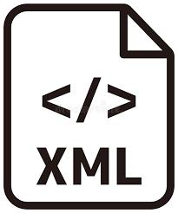

- XML
- Backend Technology
- Java
- Firebase
Fig 3.3 XML Fig 3.4 Firebase logo

3.6 Internship Project Planning

3.6.1 Internship project Development Approach and Justification
- Developed using Android Studio for the front-end and Firebase for the back-end.
- Followed a modular, role-based structure for Admin, Doctor, and Patient roles.
- Used an iterative development approach: planning → designing → coding → testing.
- Designed UI using XML and implemented logic with Java.
- Used Firebase Authentication and Realtime Database for secure and real-time data handling.
- Chose Android and Firebase for easy integration, scalability, and cost-effectiveness.
- The structure ensures security, better user experience, and easier maintenance.

3.6.2 Internship Effort and Time, Cost Estimation
In internship, I worked for around 8.5 hours per day on designing, developing, testing, and documenting the Hospital Management System. The project was built using free tools like Android Studio and Firebase, so there was no major cost. Basic expenses like internet and electricity were required, but these were provided by the company.

3.6.3 Roles and Responsibilities
During my internship, I was responsible for developing the Hospital Management System. I designed the user interface, built the app using Java, and connected it to Firebase for login and data storage. I tested the app to fix bugs and improve performance. I also created basic documentation and made sure each user (Admin, Doctor, Patient) had a smooth and secure flow in the app.

3.7 Internship Scheduling
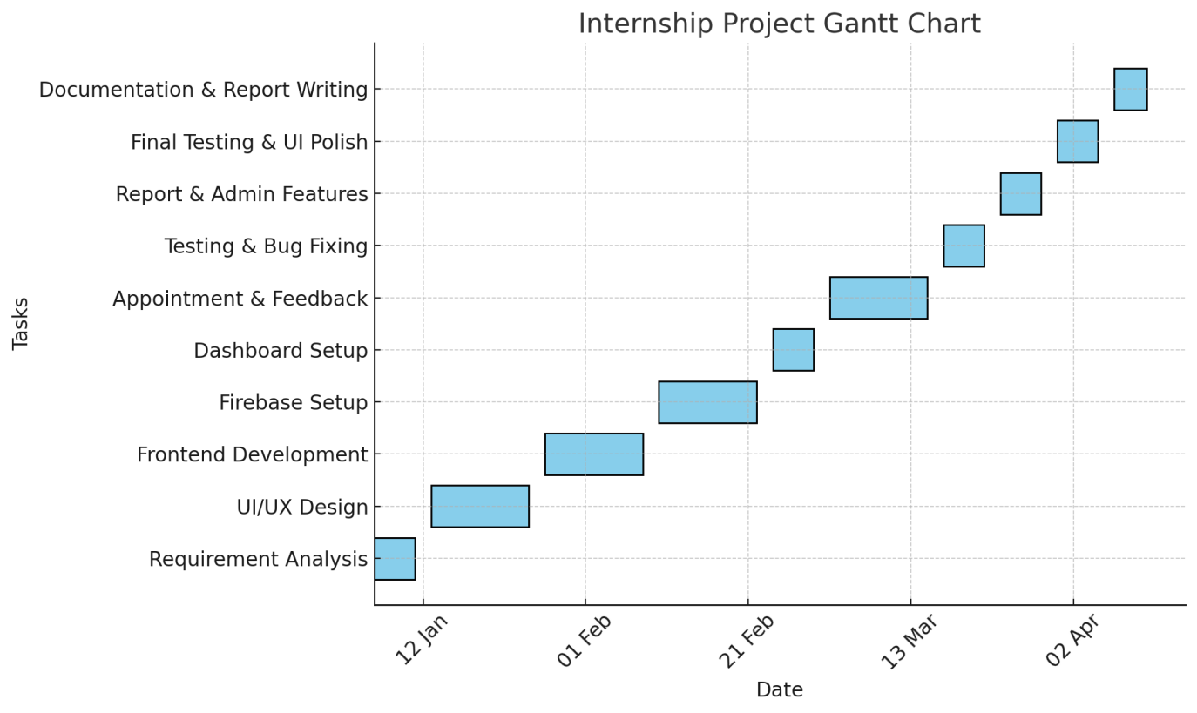
Fig 3.5 Gantt chart

CHAPTER 4
SYSTEM ANALYSIS

4.1 Study of Current System
- Hospiezee
An all-in-one digital platform offering a powerful hospital management app designed to meet the growing demands of healthcare facilities.

Features
Comprehensive patient management​
Doctor and staff scheduling​
Billing and financial management​
Inventory and pharmacy management

- ApnaOPD
A robust system designed to streamline administrative tasks, enhance communication, and improve overall patient experiences, suitable for clinics and hospitals.

Features
Outpatient department management​
Electronic medical records​
Prescription management​
Patient appointment tracking

- Fauget Medical

An all-in-one digital platform offering a powerful hospital management app designed to meet the growing demands of healthcare facilities.
Features
Comprehensive patient management​
Doctor and staff scheduling​
Billing and financial management​
- MocDoc
An all-in-one healthcare companion designed to optimize hospital operations and enhance patient care through efficient management tools.
Features
Electronic health records​
Appointment and scheduling system​
Billing and insurance processing​
Patient engagement tools​

4.2 Problem and Weaknesses of Current System
4.2.1 Problem
Most hospital management apps available on the Play Store are not easy to use. Their design is often confusing for doctors, staff, and patients. Many useful features like billing, reporting, or multi-doctor support are locked in paid versions, which makes them less helpful for small clinics or hospitals with limited budgets.
4.2.2 Weakness
These apps mostly need internet access all the time and don’t work offline. They don’t allow much customization based on hospital needs. Some apps have poor role management between admin, doctor, and patient. Data privacy is also not clear, and support is often slow. Many apps don’t include smart features like AI chat or smart appointment booking.

4.3 Requirements of New System
4.3.1 Functional Requirements
- User registration and login for doctors and patients
- Appointment booking system with doctor and date selection
- Admin can manage users and appointments
- Chatbot to help patients with common questions
- Patient profile and medical history management

4.3.2 Non-Functional Requirements
- The app should work smoothly on Android devices
- User data should be securely stored using Firebase
- The interface should be simple and easy to use
- The system should give fast responses and load quickly

4.4 System Feasibility
4.4.1 Does the system contribute to the overall objectives of the organization?
Yes, the developed Hospital Management System contributes to the overall objectives of the organization. The system helps simplify hospital tasks such as appointment booking, patient record management, and communication between doctors and patients. It improves work efficiency, reduces manual errors, and saves time for hospital staff. By using modern tools like Android and Firebase, the system offers a smart and cost-effective solution. This aligns with the organization’s goal to adopt digital solutions and provide better services to patients.
4.4.2 Can the system be implemented using the current technology and within
the given cost and schedule constraints
Yes, the system can be implemented using the current technology and within the given cost and time limits. The project uses freely available tools like Android Studio and Firebase, which reduces development costs. Since the system was developed during the internship period from 6th January 2025 to 11th April 2025, it proves that the schedule was achievable. Also, no expensive hardware or paid software was needed, making it suitable for small organizations or clinics with a limited budget.
4.4.3 Can the system be integrated with other systems which are already in
place?
Yes, the system can be integrated with other existing systems. It uses Firebase and standard technologies that support API integration, making it easy to connect with hospital websites, billing systems, or third-party apps. The system is flexible and can be expanded in the future to work with other healthcare tools or platforms.

4.5 Activity / Process in New System / Proposed System
- Patient Registration & Login – Patients can create an account and securely log in.
- Appointment Booking – Patients can select doctors, view availability, and book appointments.
- Doctor Dashboard – Doctors can view patient details, appointment schedules, and update records.
- Admin Management – Admin can manage users (doctors and patients), appointments, and system settings.
- Chatbot Assistance – AI-based chatbot helps users with basic queries and guides them in the app.

4.6 Features of New System / Proposed System
- User-Friendly Interface: Easy-to-navigate design ensuring a smooth experience for all users.
- Doctor Listing: View detailed profiles of available doctors with specialization and availability.
- Online Appointment Booking: Book appointments with doctors anytime, anywhere through the app.
- Chatbot Support: Get instant answers and guidance with integrated AI-powered chatbot assistance.
- Admin Panel: Manage doctors, patients, and appointments efficiently from a centralized dashboard.
- Real-Time Data: Access up-to-date information for appointments, feedback, and system activities.
- Secure Login: Protect user data with authentication for patients, doctors, and admins.
- Mobile App-Based: All features accessible on-the-go through a fully functional mobile application.

4.7 List Main Modules / Components / Processes / Techniques of New System / Proposed System
Main Modules:
- User Module – Handles patient and doctor login/registration
- Appointment Module – Manages booking, rescheduling, and canceling appointments
- Admin Module – Manages doctors, patients, and appointments
- Chatbot Module – Provides assistance to users for common queries
System Components:
- Android Application – Frontend for user interaction
- Firebase Database – Backend for data storage and real-time updates
- Authentication System – Ensures secure login for users
- RecyclerView & UI Components – Displays user data in a clean format
Techniques Used:
- Firebase Integration for real-time database
- Android Studio for mobile app development
- Material Design for UI/UX
- Dialogflow for chatbot functionality

4.8 Selection of Hardware / Software / Algorithms / Methodology / Techniques /Approaches and Justification
Hardware:
- Android Mobile Device – For testing and running the app
- Computer/Laptop – For development using Android Studio
Software:
- Android Studio – For app development
- Firebase – For database, authentication, and notifications
- Dialogflow – For implementing AI chatbot

CHAPTER 5
SYSTEM DESIGN

5.1 System Design & Methodology
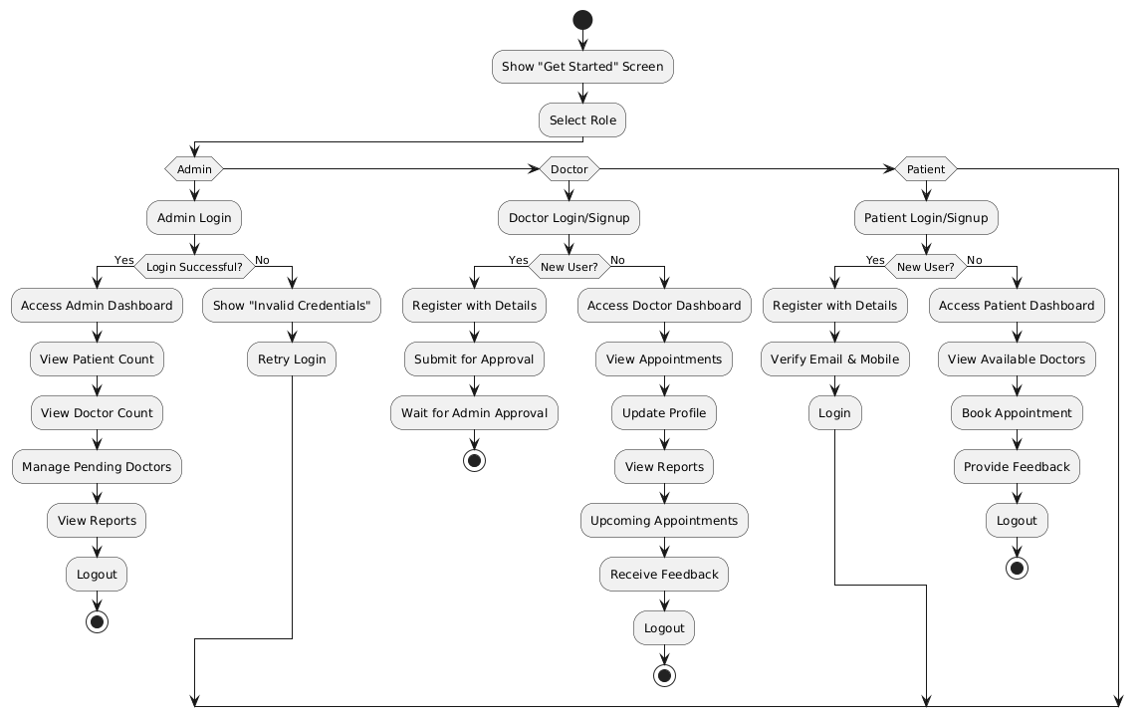
Fig 5.1 Flowchart
The above flowchart represents the complete workflow of the Hospital Management System developed during the internship. It is divided into three main roles: Admin, Doctor, and Patient. The flow starts from the "Get Started" screen, where the user selects their role to continue.
Admin Flow:
- The admin logs in with credentials.
- If login is successful, the admin dashboard is shown.
- The admin can view the patient and doctor count, manage pending doctor approvals, and view reports.
- The process ends with logout.

Doctor Flow:
- If a doctor is a new user, they register and submit their details for admin approval.
- If already registered, the doctor logs in and accesses their dashboard.
- Features available include viewing appointments, updating profiles, checking reports, managing upcoming appointments, and receiving feedback.
- The doctor can log out after completing tasks.

Patient Flow:
- New patients register by entering their details and verifying email and mobile.
- Existing patients directly log in and access their dashboard.
- Features include viewing available doctors, booking appointments, and giving feedback.
- The patient also ends the session with logout.

5.2 Database Design / Data Structure Design / Process Design / Structure Design / ER Diagram / DFD /UML etc.
Table 5.1 patient_table
Column Name | Data Type | Description
patient_id | INT | Unique ID for each patient
name | VARCHAR(255) | Patient's full name
gender | VARCHAR(50) | Gender
dob | DATE | Date of birth
email | VARCHAR(255) | Email address
phone | VARCHAR(20) | Contact number

Table 5.2 doctor_table
Column Name | Data Type | Description
doctor_id | INT | Unique ID for each doctor
name | VARCHAR(255) | Doctor's full name
gender | VARCHAR(50) | Gender
dob | DATE | Date of birth
email | VARCHAR(255) | Email address
phone | VARCHAR(20) | Contact number
specialization | VARCHAR(255) | Medical specialization
experience | INT | Years of experience

Table 5.3 appointment_table
Column Name | Data Type | Description
appointment_id | INT | Unique ID for appointment
doctor_id | INT | ID of the assigned doctor
patient_id | INT | ID of the patient
date | DATE | Appointment date
time | TIME | Appointment time
availability | VARCHAR(100) | Availability status of the doctor

Table 5.4 record_table
Column Name | Data Type | Description
record_id | INT | Unique ID for the medical record
patient_id | INT | ID of the patient
doctor_id | INT | ID of the doctor
diagnosis | TEXT | Diagnosis details
5.3 Input / Output and Interface Design
5.3.1 Use case Diagram
Fig 5.2 Use case diagram
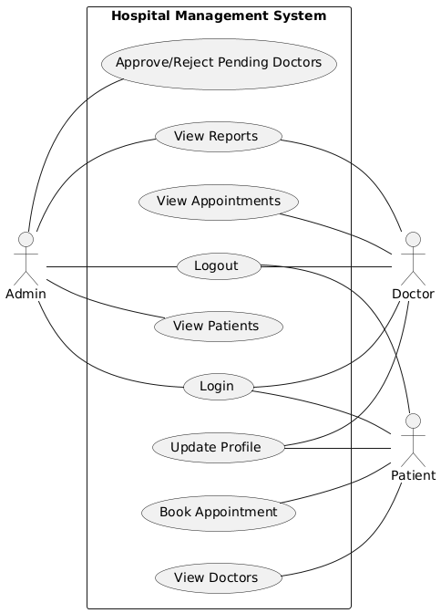
Admin Module
- Can Login to the system.
- Can Logout from the system.
- Can Approve/Reject Pending Doctors.
- Can View Reports.
- Can View Appointments of all patients.
- Can View Patients information.
- Can Update Profile.
Doctor Module
- Can Login to the system.
- Can Logout from the system.
- Can View Appointments assigned to them.
- Can View Patients assigned to them.
- Can Update Profile.
Patient Module
- Can Login to the system.
- Can Logout from the system.
- Can View Doctors available for consultation.
- Can Book Appointment with doctors.
- can Update Profile.
5.3.2 ER- Diagram
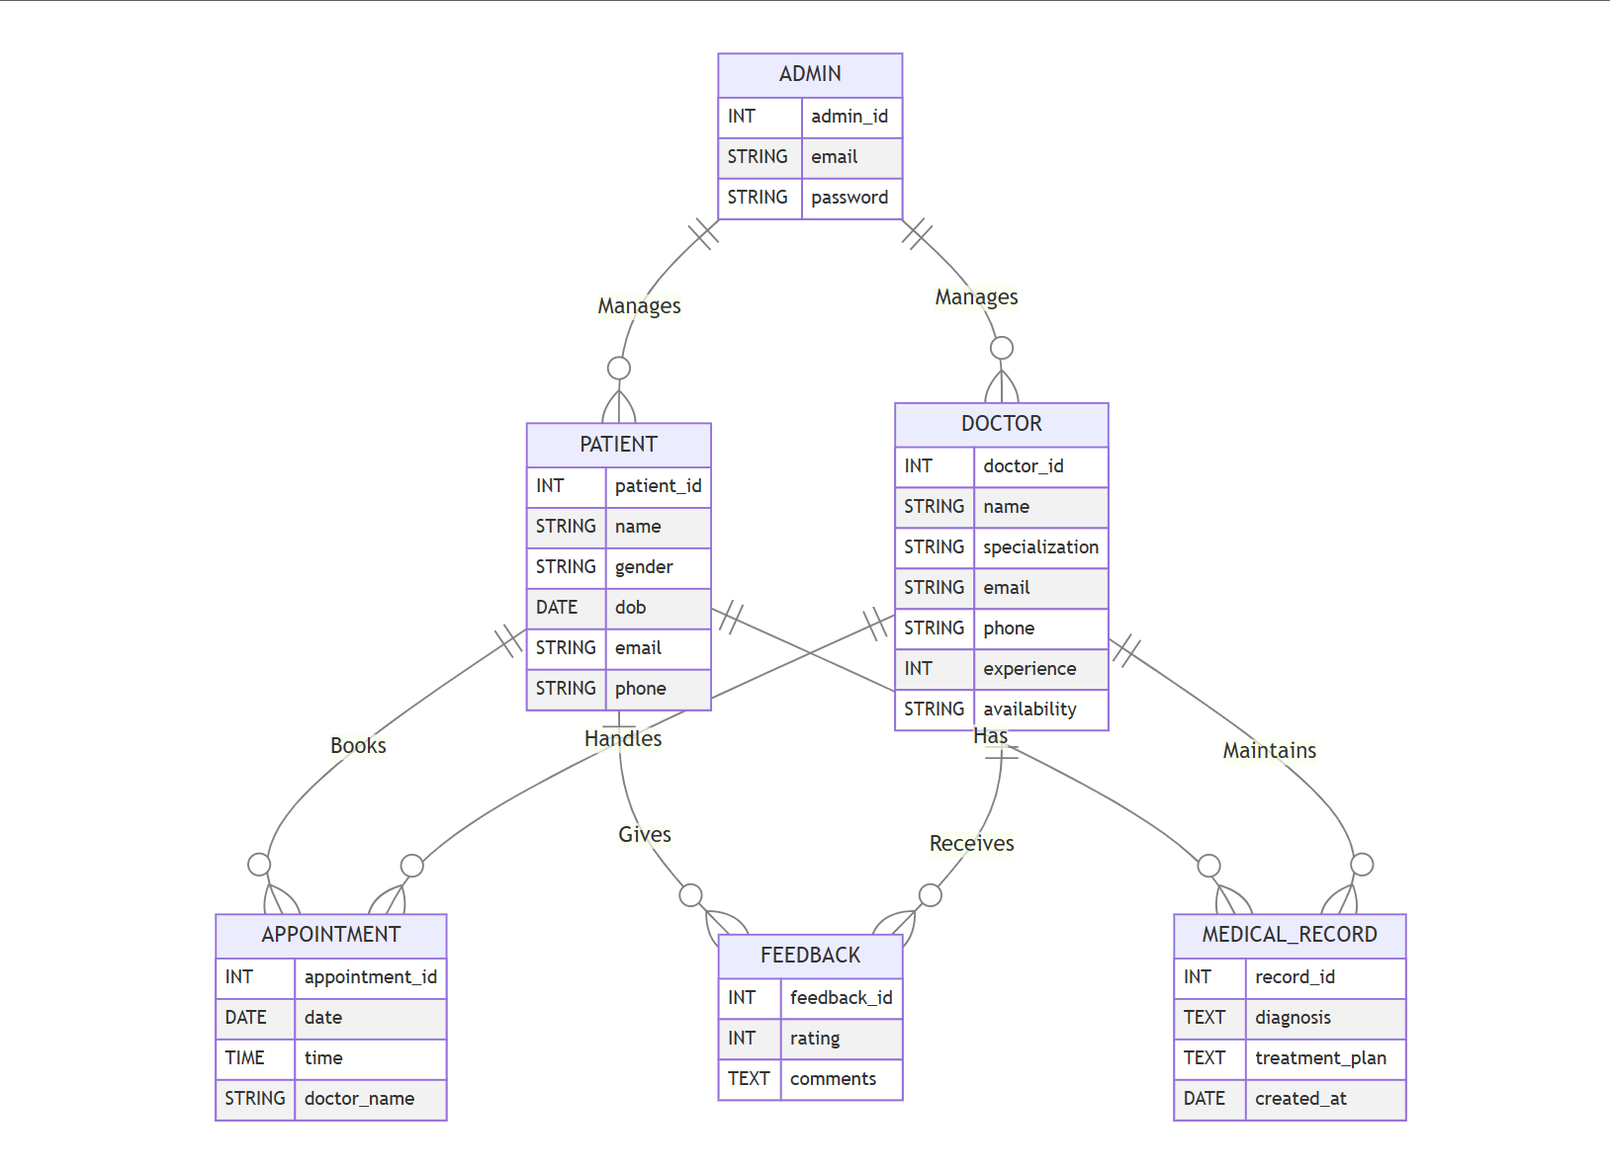
Fig 5.3 ER diagram

5.3.3 Sequence Diagram

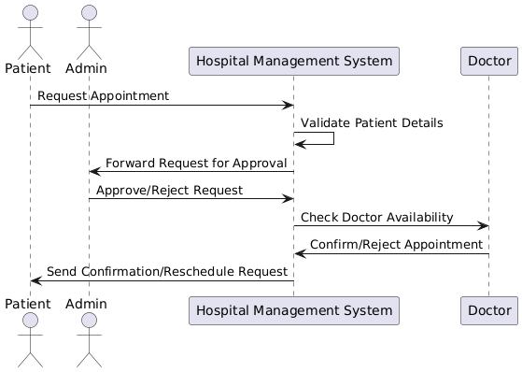
Fig 5.4 Sequence diagram

CHAPTER 6
IMPLEMENTATION & TESTING

6.1 Implementation Platform / Environment
- Platform: Android Operating System
- Development Environment: Android Studio (Latest Stable Version)
- Programming Language: Java
- Database: Firebase Realtime Database
- Authentication: Firebase Authentication (Email/Password-based)
- UI Design: XML Layouts, Material Design Components
- Minimum SDK Version: 21 (Android 5.0 Lollipop)
- Testing Devices: Android Emulator and Physical Devices (Android phones)

6.2 Process / Program / Technology / Modules Specification
6.2.1 Login Activity
This module allows all users (Admin, Doctor, Patient) to securely log in to the Hospital Management System using their registered credentials. Proper validation and authentication are implemented to ensure secure access.

6.2.2 Sign_Up Activity
This activity provides a registration interface for new users. Doctors and Patients can register through this module. Doctor registrations remain in a pending state until reviewed and approved by the Admin.

6.2.3 Appointment Activity
- Book Appointment: Patients can book appointments with doctors by selecting available time slots.
- View Appointments: Doctors and Admin can view the list of scheduled appointments.
- Manage Appointments: Doctors can manage their appointments, check availability, and prepare accordingly.

6.2.4 Doctor Management Activity
- Approve/Reject Doctors: Admin has the authority to approve or reject newly registered doctors.
- View Doctors: Patients can view the list of approved doctors along with their specializations and availability.

6.2.5 Patient Management Activity
- View Patients: Doctors and Admin can access the profiles and appointment history of patients.
- Patient Info: Displays essential medical details, history, and booking records related to the patient.

6.2.6 Profile Activity
This activity allows all users to view and manage their personal profile information. Users can update their details such as name, contact information, and other related data.

6.2.7 Report Activity
This module is accessible to the Admin and is used to generate and view various system-related reports. These include data on appointments, registered users, doctor approvals, and general activity logs.

6.2.8 Home Page Activity
This is the default dashboard shown after login based on the user type:
- Admin: Displays pending doctor approvals, system reports, and a quick summary of activities.
- Doctor: Shows daily appointments and patient-related notifications.
- Patient: Displays upcoming appointments and recommended doctors.

6.3 Implementation
6.3.1 Admin_login_activity
- Login page
<?xml version="1.0" encoding="utf-8"?>
<LinearLayout
xmlns:android="http://schemas.android.com/apk/res/android"
android:layout_width="match_parent"
android:layout_height="match_parent"
xmlns:tools="http://schemas.android.com/tools"
android:orientation="vertical"
android:gravity="center"
android:padding="16dp"
tools:context=".AdminLoginActivity"
android:background="@drawable/back">
<ImageView
android:id="@+id/AdminLogo"
android:layout_width="300dp"
android:layout_height="200dp"
android:src="@drawable/logo"
android:contentDescription="Admin Logo"
android:layout_marginBottom="30dp" />
<TextView
android:id="@+id/Adminlogin"
android:layout_width="wrap_content"
android:layout_height="wrap_content"
android:text="Admin Login"
android:textSize="28sp” />

6.3.2 Admin_dashboard_activity
- Dashboard
<?xml version="1.0" encoding="utf-8"?>
<ScrollView xmlns:android="http://schemas.android.com/apk/res/android"
android:layout_width="match_parent"
android:layout_height="match_parent"
android:background="@drawable/back">
<LinearLayout
android:layout_width="match_parent"
android:layout_height="wrap_content"
android:orientation="vertical"
android:padding="16dp">
<TextView
android:id="@+id/dashboard_title"
android:layout_width="match_parent"
android:layout_height="wrap_content"
android:text="Admin Dashboard"
android:textSize="30sp"
android:textColor="#000000"
android:textStyle="bold"
android:fontFamily="serif"
android:gravity="center" />

- Patients details

<?xml version="1.0" encoding="utf-8"?>
<LinearLayout xmlns:android="http://schemas.android.com/apk/res/android"
android:layout_width="match_parent"
android:layout_height="match_parent"
android:orientation="vertical"
android:padding="16dp"
android:background="@drawable/back">
<TextView
android:layout_width="match_parent"
android:layout_height="wrap_content"
android:text="Patients Details"
android:textSize="30sp"
android:textColor="#000000"
android:textStyle="bold"
android:gravity="center"
android:padding="8dp" />
<ListView
android:id="@+id/patients_list"
android:layout_width="match_parent"
android:layout_height="wrap_content"
android:layout_marginTop="16dp" />

- Doctors details

<?xml version="1.0" encoding="utf-8"?>
<LinearLayout xmlns:android="http://schemas.android.com/apk/res/android"
android:layout_width="match_parent"
android:layout_height="match_parent"
android:orientation="vertical"
android:padding="16dp"
android:background="@drawable/back">
<TextView
android:layout_width="match_parent"
android:layout_height="wrap_content"
android:text="Doctors Details"
android:textSize="30sp"
android:textColor="#000000"
android:textStyle="bold"
android:gravity="center"
android:padding="8dp" />
<ListView
android:id="@+id/doctors_list"
android:layout_width="match_parent"
android:layout_height="wrap_content"
android:layout_marginTop="16dp" />

- Approve doctor

<?xml version="1.0" encoding="utf-8"?>
<LinearLayout xmlns:android="http://schemas.android.com/apk/res/android"
android:layout_width="match_parent"
android:layout_height="match_parent"
android:orientation="vertical"
android:background="@drawable/back"
android:padding="16dp">
<TextView
android:layout_width="wrap_content"
android:layout_height="wrap_content"
android:text="Pending Doctor Approvals"
android:textSize="20sp"
android:textStyle="bold"
android:textColor="@color/black"
android:paddingBottom="10dp"/>
<ListView
android:id="@+id/pending_doctors_list"
android:layout_width="match_parent"
android:layout_height="wrap_content"
android:divider="@android:color/darker_gray"
android:dividerHeight="1dp"/>

6.3.3 Patient/Doctor_login_activity
- Loginpage

<?xml version="1.0" encoding="utf-8"?>
<LinearLayout xmlns:android="http://schemas.android.com/apk/res/android"
android:layout_width="match_parent"
android:layout_height="match_parent"
xmlns:tools="http://schemas.android.com/tools"
android:orientation="vertical"
android:padding="16dp"
tools:context=".LoginActivity"
android:background="@drawable/back">
<ImageView
android:id="@+id/ivLogo"
android:layout_width="300dp"
android:layout_height="200dp"
android:src="@drawable/logo"
android:contentDescription="App Logo"
android:layout_marginBottom="30dp" />
<TextView
android:id="@+id/tvLoginHeader"
android:layout_width="wrap_content"
android:layout_height="wrap_content"
android:text="Doctor Login"
android:textSize="28sp"
android:layout_marginBottom="32dp"
android:fontFamily="serif"/>

- Sign-up page

<?xml version="1.0" encoding="utf-8"?>
<LinearLayout xmlns:android="http://schemas.android.com/apk/res/android"
android:layout_width="match_parent"
android:layout_height="match_parent"
xmlns:tools="http://schemas.android.com/tools"
android:orientation="vertical"
android:gravity="center"
android:padding="16dp"
tools:context=".PatientRegisterActivity"
android:background="@drawable/back">
<ImageView
android:id="@+id/ivLogo"
android:layout_width="300dp"
android:layout_height="200dp"
android:src="@drawable/logo"
android:contentDescription="App Logo"
android:layout_marginBottom="30dp" />
<TextView
android:id="@+id/tvRegisterHeader"
android:layout_width="wrap_content"
android:layout_height="wrap_content"
android:text="Register as Patient"
android:layout_marginBottom="32dp"
android:fontFamily="serif"/>

- Forgot password

<?xml version="1.0" encoding="utf-8"?>
<androidx.constraintlayout.widget.ConstraintLayout xmlns:android="http://schemas.android.com/apk/res/android"
xmlns:app="http://schemas.android.com/apk/res-auto"
xmlns:tools="http://schemas.android.com/tools"
android:id="@+id/forgotPasswordPage"
android:layout_width="match_parent"
android:layout_height="match_parent"
android:background="@drawable/back"
tools:context=".ForgotPasswordActivity">
<ImageView
android:id="@+id/ivLogo"
android:layout_width="250dp"
android:layout_height="250dp"
android:src="@drawable/logo"
android:contentDescription="App Logo"
app:layout_constraintTop_toTopOf="parent"
app:layout_constraintStart_toStartOf="parent"
app:layout_constraintEnd_toEndOf="parent"
android:layout_marginTop="40dp" />

6.3.4 Patient_home_activity
- News

<?xml version="1.0" encoding="utf-8"?>
<androidx.constraintlayout.widget.ConstraintLayout
xmlns:android="http://schemas.android.com/apk/res/android"
xmlns:app="http://schemas.android.com/apk/res-auto"
xmlns:tools="http://schemas.android.com/tools"
android:id="@+id/main"
android:layout_width="match_parent"
android:layout_height="match_parent"
android:background="@drawable/back"
tools:context=".NewsActivity">
<LinearLayout
android:id="@+id/header_section"
android:layout_width="match_parent"
android:layout_height="wrap_content"
android:orientation="horizontal"
android:background="#E3F2FD"
android:padding="16dp"
android:gravity="center_vertical"
app:layout_constraintTop_toTopOf="parent">

- Doctor

<?xml version="1.0" encoding="utf-8"?>
<androidx.constraintlayout.widget.ConstraintLayout
xmlns:android="http://schemas.android.com/apk/res/android"
xmlns:app="http://schemas.android.com/apk/res-auto"
xmlns:tools="http://schemas.android.com/tools"
android:layout_width="match_parent"
android:layout_height="match_parent"
android:background="@drawable/back"
tools:context=".DoctorsDetailsActivity">
<LinearLayout
android:id="@+id/header_section"
android:layout_width="match_parent"
android:layout_height="wrap_content"
android:orientation="horizontal"
android:background="#EEDFE6ED"
android:padding="8dp"
android:gravity="center_vertical"
app:layout_constraintTop_toTopOf="parent"
app:layout_constraintStart_toStartOf="parent"
app:layout_constraintEnd_toEndOf="parent">
<TextView
android:layout_width="0dp"
android:layout_height="wrap_content"
android:text="Find Doctors"
android:textSize="22sp"
android:textStyle="bold" />

- Appointment

<?xml version="1.0" encoding="utf-8"?>
<RelativeLayout xmlns:android="http://schemas.android.com/apk/res/android"
android:layout_width="match_parent"
android:layout_height="match_parent"
android:background="@drawable/back">
<LinearLayout
android:id="@+id/header_section"
android:layout_width="match_parent"
android:layout_height="wrap_content"
android:orientation="horizontal"
android:background="#EEDFE6ED"
android:padding="16dp"
android:gravity="center_vertical">
<TextView
android:layout_width="wrap_content"
android:layout_height="wrap_content"
android:text="Appointment"
android:textSize="22sp"
android:textColor="#000000"
android:textStyle="bold" />

- Favorite doctor

<?xml version="1.0" encoding="utf-8"?>
<androidx.constraintlayout.widget.ConstraintLayout
xmlns:android="http://schemas.android.com/apk/res/android"
xmlns:app="http://schemas.android.com/apk/res-auto"
xmlns:tools="http://schemas.android.com/tools"
android:layout_width="match_parent"
android:layout_height="match_parent"
android:background="@drawable/back"
tools:context=".FavoriteDoctorsActivity">
<LinearLayout
android:id="@+id/header_section"
android:layout_width="match_parent"
android:layout_height="wrap_content"
android:orientation="horizontal"
android:gravity="center_vertical"
android:padding="8dp"
android:background="#EEDFE6ED"
app:layout_constraintTop_toTopOf="parent"
app:layout_constraintStart_toStartOf="parent"
app:layout_constraintEnd_toEndOf="parent">

- Update profile

<?xml version="1.0" encoding="utf-8"?>
<ScrollView xmlns:android="http://schemas.android.com/apk/res/android"
xmlns:tools="http://schemas.android.com/tools"
android:layout_width="match_parent"
android:layout_height="match_parent"
android:fillViewport="true"
android:background="@drawable/back"
tools:context=".UpdateProfileActivity">
<LinearLayout
android:layout_width="match_parent"
android:layout_height="wrap_content"
android:orientation="vertical"
android:gravity="center"
android:padding="16dp">
<ImageView
android:id="@+id/ivLogo"
android:layout_width="200dp"
android:layout_height="200dp"
android:src="@drawable/logo"
android:contentDescription="App Logo"
android:layout_marginBottom="20dp" />

6.3.5 Doctor_home_activity
- Home page

<?xml version="1.0" encoding="utf-8"?>
<ScrollView xmlns:android="http://schemas.android.com/apk/res/android"
android:layout_width="match_parent"
android:layout_height="match_parent"
xmlns:tools="http://schemas.android.com/tools"
tools:context=".DoctorHomeActivity"
android:background="@drawable/back">
<LinearLayout
android:layout_width="match_parent"
android:layout_height="wrap_content"
android:orientation="vertical"
android:padding="16dp">
<TextView
android:id="@+id/doctor_dashboard_title"
android:layout_width="match_parent"
android:layout_height="wrap_content"
android:text="Doctor Dashboard"
android:textSize="26sp"
android:textColor="#4CAF50"
android:fontFamily="serif"
android:gravity="center"
android:padding="8dp" />

- All appointment

<?xml version="1.0" encoding="utf-8"?>
<LinearLayout xmlns:android="http://schemas.android.com/apk/res/android"
android:layout_width="match_parent"
android:layout_height="match_parent"
android:padding="16dp"
android:orientation="vertical"
android:gravity="center_horizontal"
android:background="@android:color/white">
<TextView
android:layout_width="wrap_content"
android:layout_height="wrap_content"
android:text="Appointments"
android:textSize="22sp"
android:textStyle="bold"
android:textColor="@android:color/black"
android:paddingBottom="12dp"/>
<ScrollView
android:layout_width="match_parent"
android:layout_height="0dp"
android:layout_weight="1">
<HorizontalScrollView
android:layout_width="match_parent"
android:layout_height="wrap_content">

6.3.6 Feedback_activity
- Feedback

<?xml version="1.0" encoding="utf-8"?>
<LinearLayout xmlns:android="http://schemas.android.com/apk/res/android"
android:orientation="vertical"
android:padding="20dp"
android:background="@drawable/back"
android:layout_width="match_parent"
android:layout_height="wrap_content">
<LinearLayout android:orientation="vertical"
android:padding="20dp"
android:background="@drawable/rounded_edittext"
android:layout_width="match_parent"
android:layout_height="200dp">
<TextView
android:text="Select Your Feedback"
android:textSize="16sp"
android:layout_marginBottom="10dp"
android:layout_width="wrap_content"
android:layout_height="wrap_content" />

6.3.7 Categories_activity
- Categories

<?xml version="1.0" encoding="utf-8"?>
<androidx.constraintlayout.widget.ConstraintLayout xmlns:android="http://schemas.android.com/apk/res/android"
xmlns:app="http://schemas.android.com/apk/res-auto"
xmlns:tools="http://schemas.android.com/tools"
android:id="@+id/categories"
android:layout_width="match_parent"
android:layout_height="990dp"
android:background="@drawable/back"
tools:context=".CategoriesActivity">
<TextView
android:id="@+id/tvCategoriesHeader"
android:layout_width="wrap_content"
android:layout_height="wrap_content"
android:text="Select Category"
android:textSize="40sp"
android:textColor="#000000"
android:textStyle="bold"
android:fontFamily="serif"
android:layout_marginTop="80dp"
app:layout_constraintTop_toTopOf="parent"
app:layout_constraintStart_toStartOf="parent"
app:layout_constraintEnd_toEndOf="parent"
android:layout_marginBottom="50dp"/>

6.4 Finding / Results / Outcomes
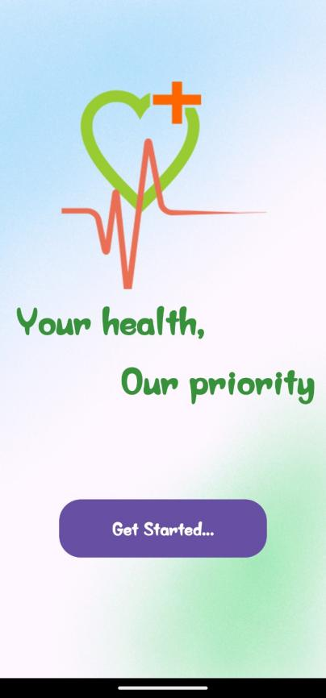
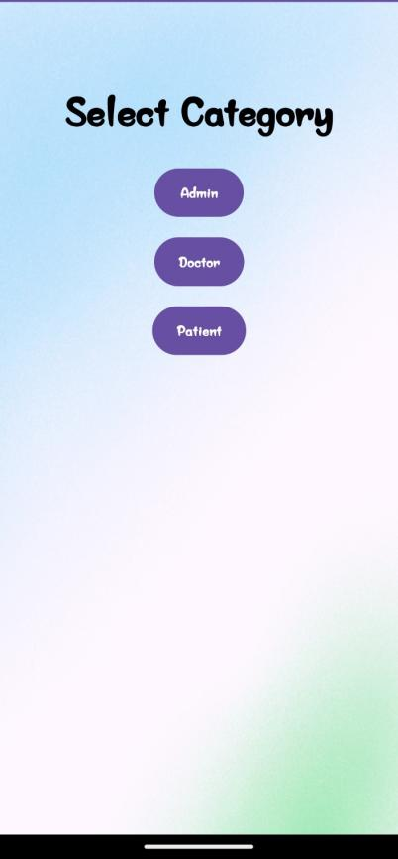
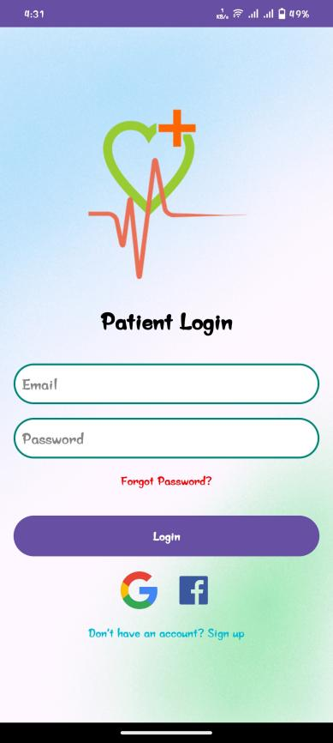
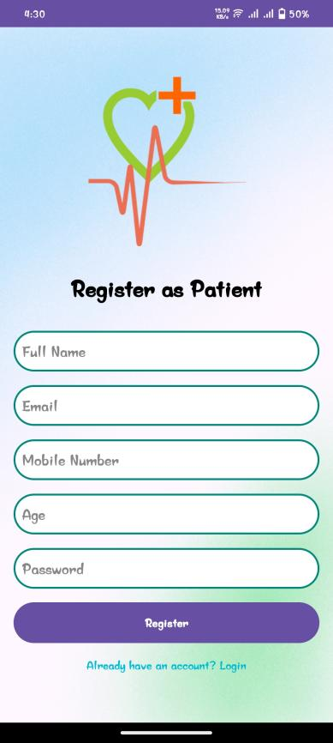
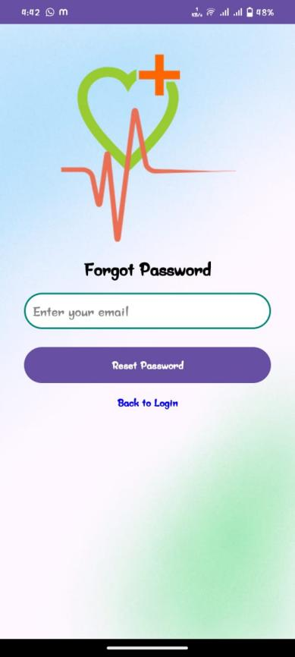
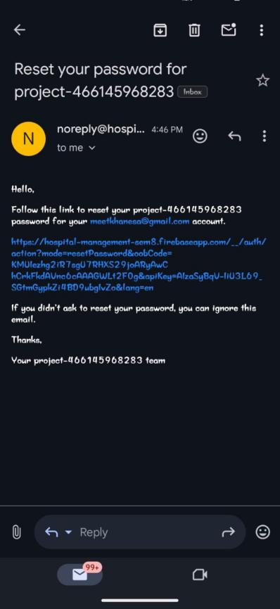

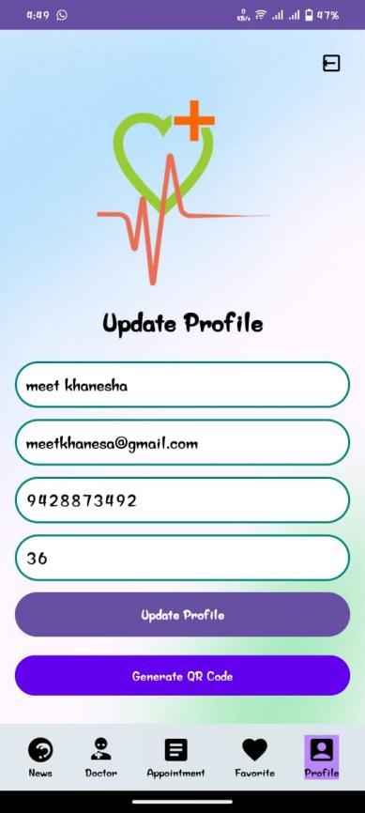
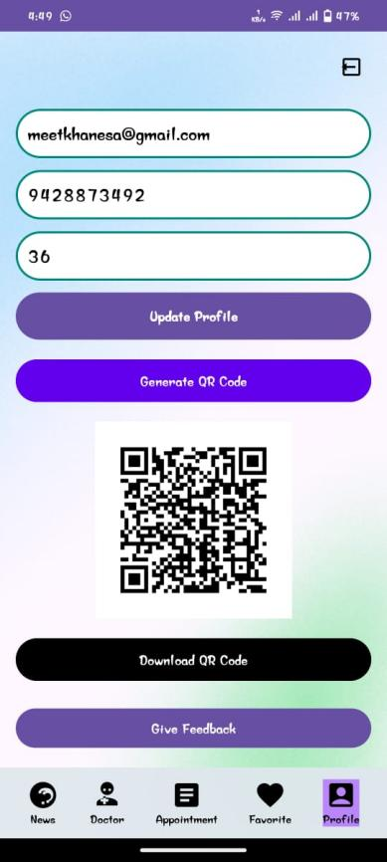
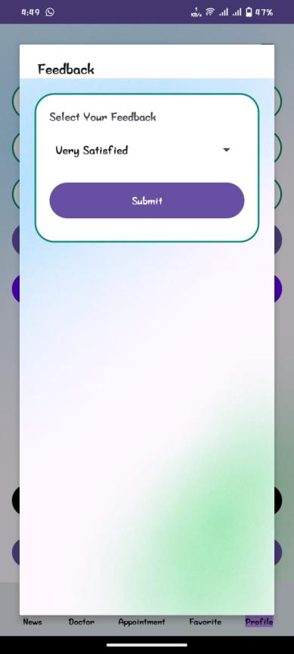

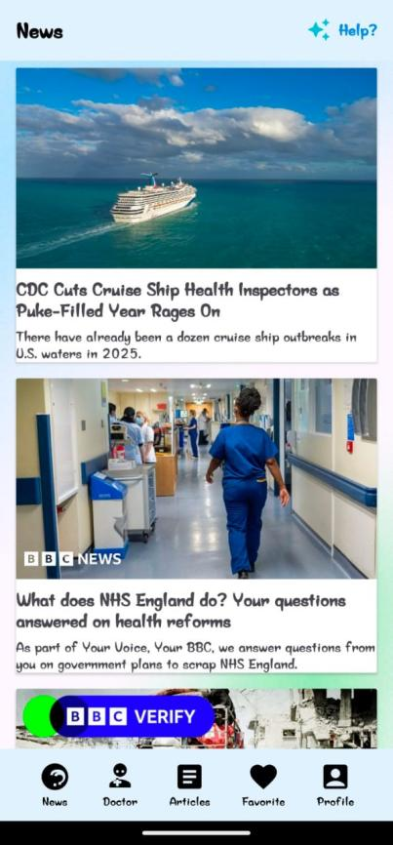
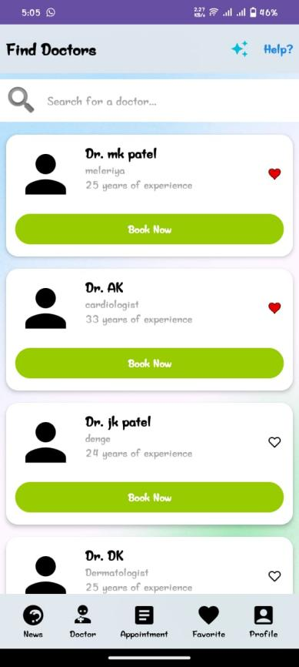
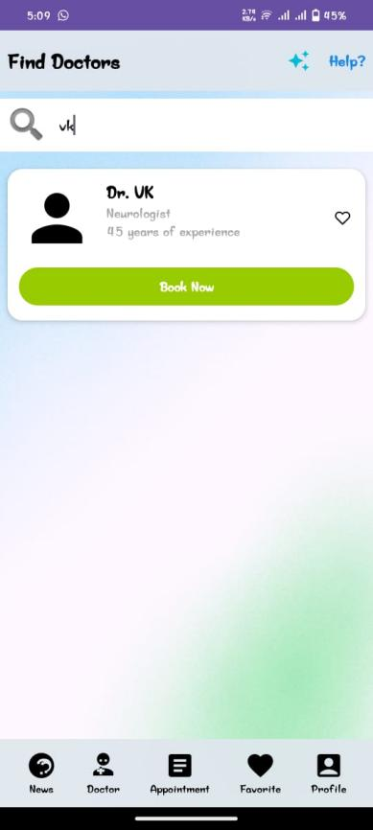

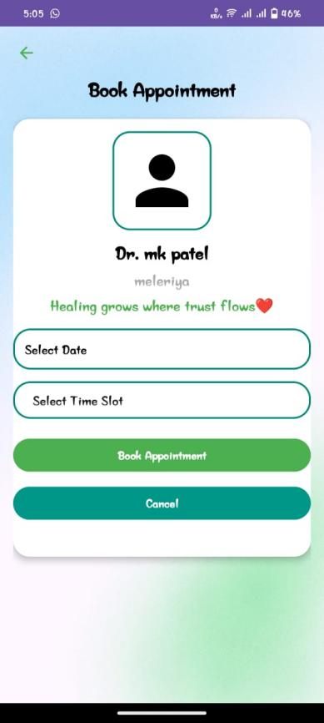
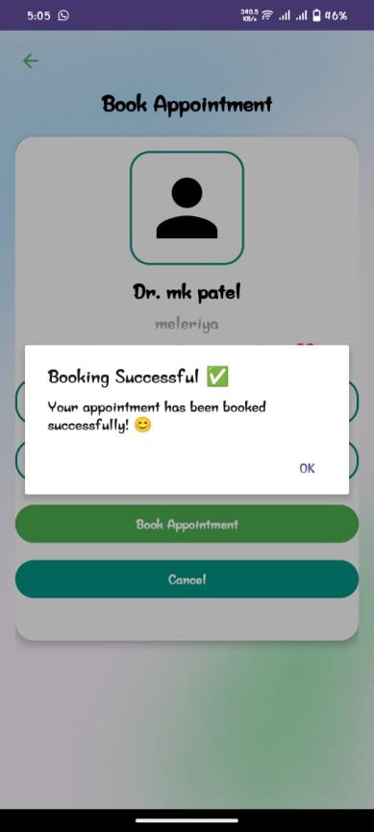
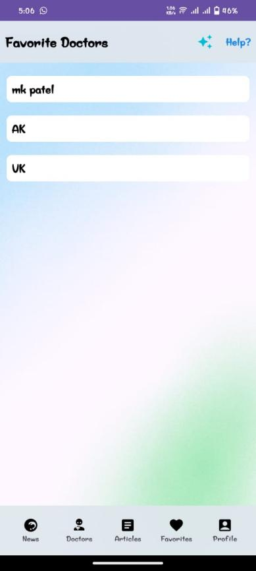

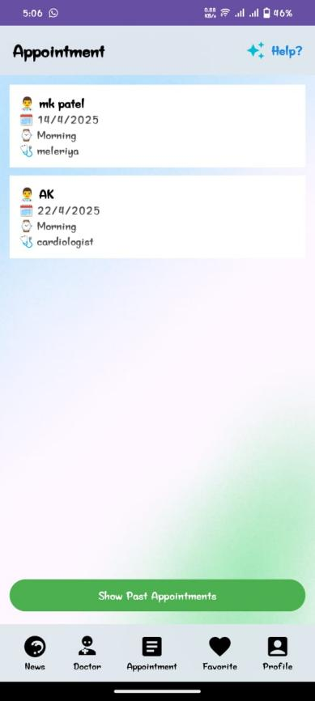
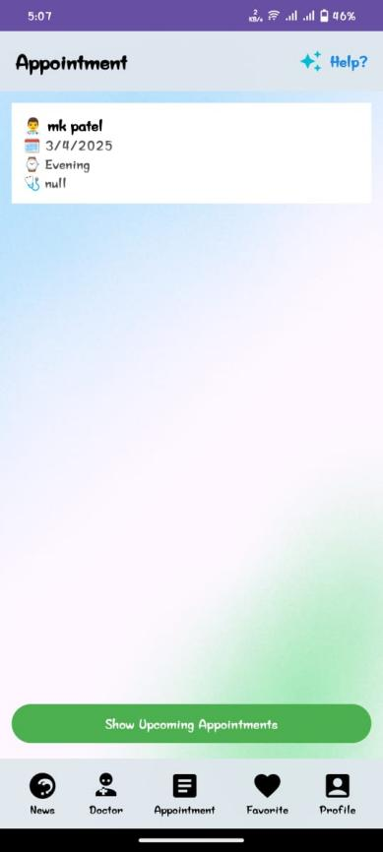
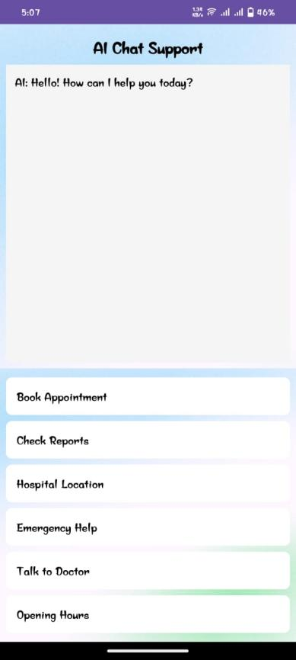

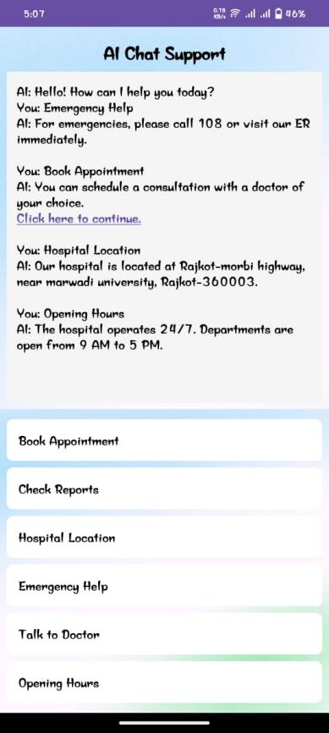
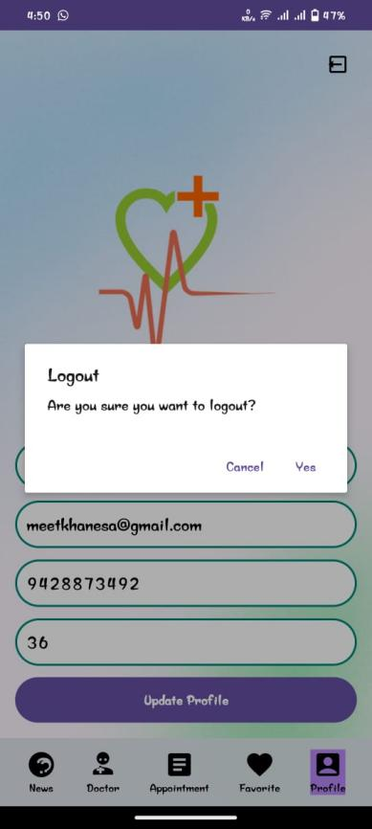
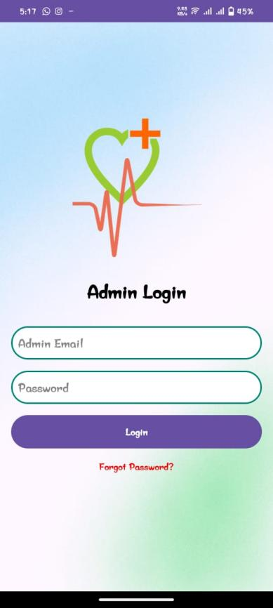

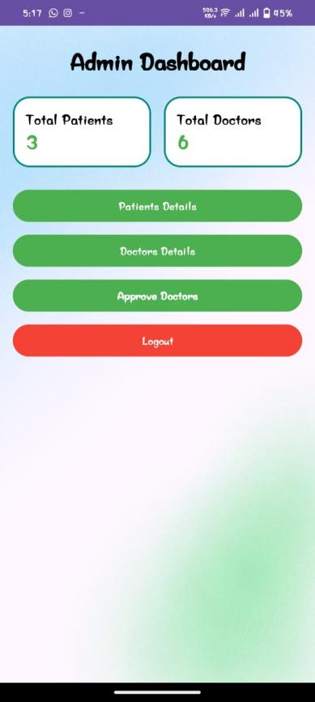
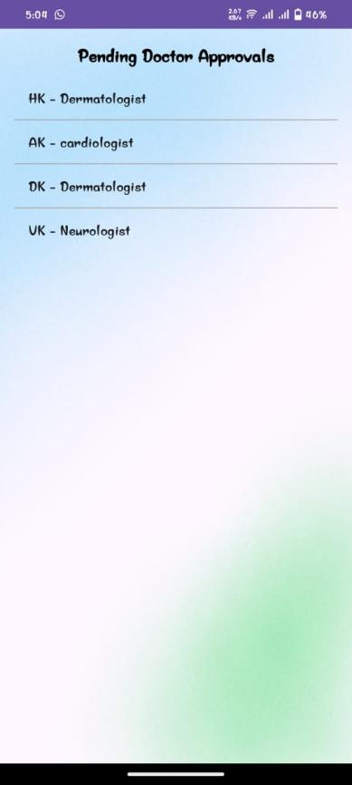
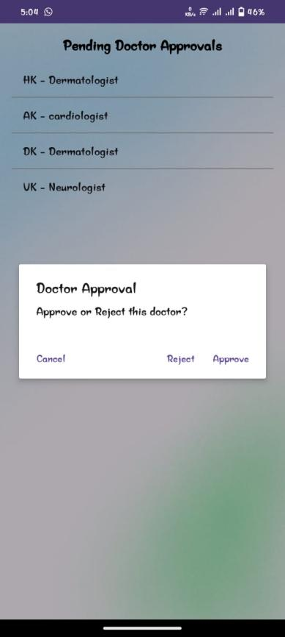

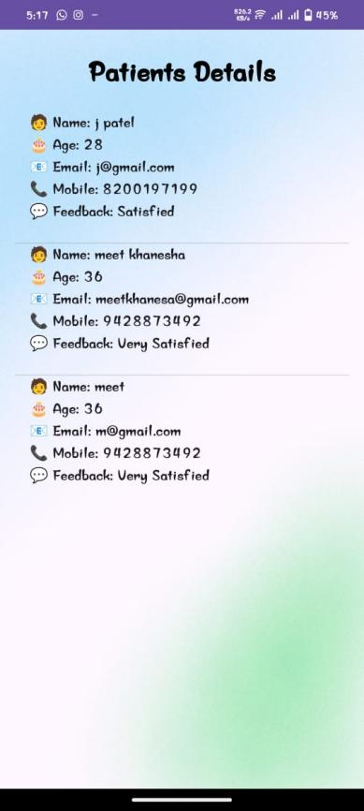
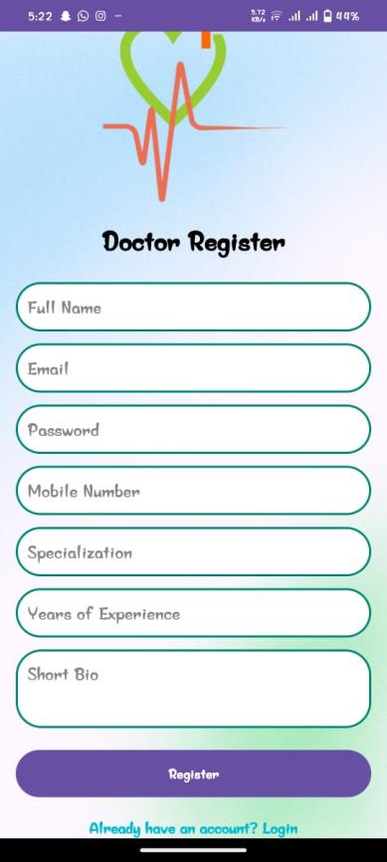
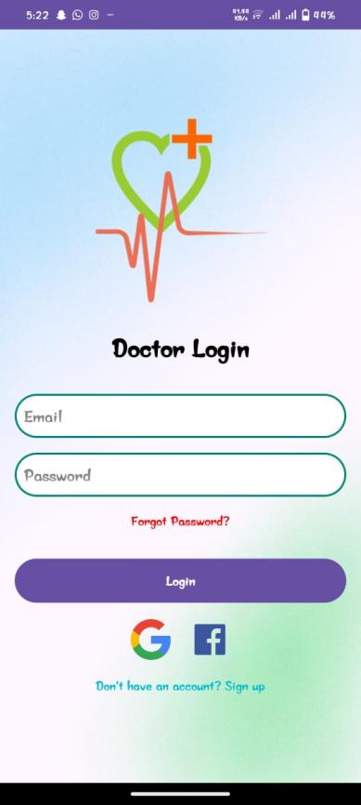
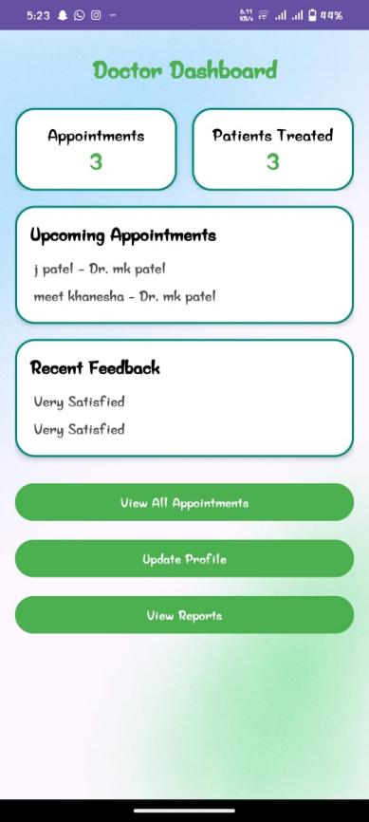
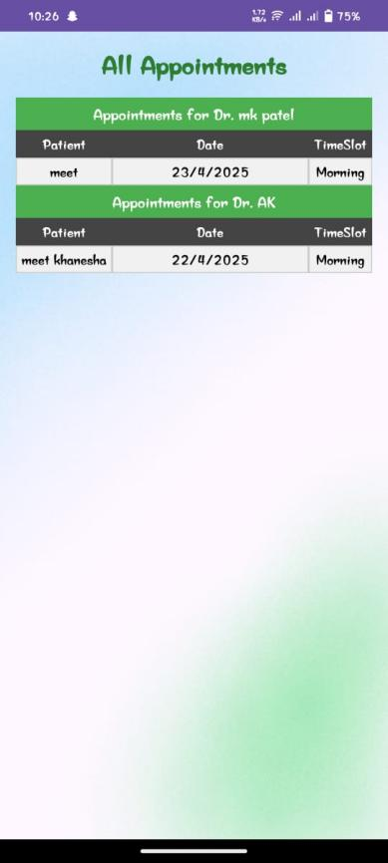
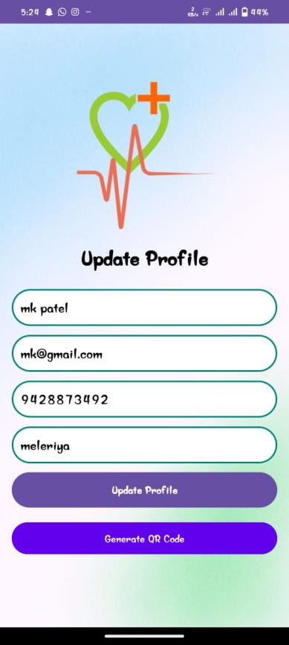

6.5 Testing Plan / Strategy
- Compatibility Testing: We'll test the app on various devices, such as different models of smartphones and tablets, to ensure it works well on all of them.
- Performance Testing: We'll test how fast the app loads and how smoothly it runs, especially when there are many users using it at the same time.
- Unit Testing: We'll check each feature of the app individually. For example, we'll test if the login button works correctly by clicking on it and making sure it takes users to the login screen.
- Integration Testing: We'll test how different parts of the app work together. For instance, we'll check if users can add a pet to their favorites and then view it on their profile page.
- User Testing: Real users will try out the app. They'll be asked to perform tasks like finding a pet to adopt or posting on the community forum. Their feedback will help us improve the app.

6.6 Test Results and Analysis
6.6.1 Test cases
Test ID | Test condition | Expected Output | Actual output | Remark
TC-1 | User enters  valid username  and password | User  successfully  logs into the app | User  successfully  login | Working
TC-2 | User enters  invalid  username and  password | App displays an  error message | App display  error | Working
TC-3 | User check  Doctor status | Status is not display | User don’t check status | Error
TC-4 | User book appointment | Appointment book successful | User book appointment successful | Workin
TC-5 | user dowanload  QR photo | Yes download and scan to display details | Toast message  display image download and save photo in storage | Working

6.6.2 Result Analysis / Comparison
The table presents a set of test cases (TC) along with their respective test conditions,
expected outputs, actual outputs, and remarks. Each test case evaluates different
functionalities or scenarios within the app.
TC-1 verifies successful login with valid credentials, TC-2 checks error handling for
invalid login attempts, TC-3 assesses the absence of a toast message when checking doctor
status, TC-4 confirms the functionality of booking Appointment, and TC-5 examines
Downloading QR photos and scan to display details.

CHAPTER 7
CONCLUSION AND FUTURE ENHANCEMENTS

7.1 Overall Analysis of Internship Vi-abilities
The Hospital Management System developed during the internship is a highly viable project with strong potential for real-world implementation. It effectively streamlines core hospital functions such as appointment booking, patient feedback, doctor management, and real-time data handling. Built using Android Studio and Firebase, the app ensures reliability, scalability, and ease of use for both patients and doctors. Its user-friendly interface makes healthcare access more convenient and efficient. The project also supports future integration of advanced features like AI-based chat-boat and analytical reports. Overall, this system provides a digital solution to common hospital management challenges and has the potential for long-term growth with regular updates and enhancements.

7.2 Problem Encountered and Possible Solutions
During the development of the Hospital Management System app, several challenges were encountered such as integrating Firebase for real-time data handling, ensuring smooth user navigation, and managing dynamic data like appointments and feedback. At times, syncing data between different user roles (doctors, patients, and admin) was complex. These issues were tackled through proper debugging, referring to Firebase and Android documentation, and continuous testing on multiple devices. Implementing clear UI/UX principles helped reduce user confusion. Ensuring data security and validating inputs were also crucial. With careful planning and regular improvements, these problems were successfully resolved, resulting in a smooth and reliable application.

7.3 Summary of Internship work
The internship project involved the development of a Hospital Management System Android application. The app, built using Android Studio, Java, and Firebase, aimed to streamline hospital operations by enabling features like appointment booking, doctor management, real-time data synchronization, and user profile management. The system allows patients to book appointments with doctors, view available time slots, and provide feedback, while doctors can manage their schedules and interact with patients. During the development, challenges such as database synchronization, real-time updates, and integrating Firebase were encountered. These were addressed through thorough testing, debugging, and utilizing online resources. The project successfully delivered a user-friendly, efficient, and secure system that enhanced both patient and healthcare provider experiences.

7.4 Limitations
The limitations of the Hospital Management System app stem from constraints related to time, resources, and the expertise available during the internship. While the app successfully handles basic functionalities like appointment booking, doctor management, and profile updates, certain advanced features were not fully implemented due to these constraints. Additionally, the user interface and user experience could be further improved, and some areas of the app may need more robust testing to ensure reliability under various conditions.

7.5 Future Enhancement
Future enhancements for the app could include adding push notifications to keep patients and doctors informed of upcoming appointments or important updates. Integrating social media for user engagement and feedback sharing would allow for greater community interaction. Moreover, the app could be localized to support multiple languages, catering to a broader audience and improving accessibility for users from different regions. Expanding the system’s functionality with features such as medicine integration and real-time health monitoring would further enhance its capabilities.

